|  |  |
| --- | --- |
| **STUDENT NAME** | Harrison Went |
| **PROJECT NAME** | Escape Room |
| What do you think went well on the project? | The team communication of our group was effective throughout the project making use of email communication with the client and regular meetings held on discord to discuss setting tasks, checking up on progress and developing the project further. This communication played an important part in getting our playable prototype and final build of the project complete with all of the features we set out to implement.  When looking at the design of the game we developed I believe it meets most of the criteria set out in the brief, which we identified as a multi-player cooperative puzzle game, loosely based on escape room genre of games.  The final product we developed is to a high quality and standard with reliable performance and a feature complete experience with well designed puzzles, sound and art direction. |
| What do you think needed improvement on the project? | The re-playability of the final version of the game is somewhat limited. I think this is due to a lack of content such as variants of each puzzle and the total amount of puzzles, I put this down to time constraints to complete the project.  The game should have been prototyped and tested more by players and the client to better gauge experience as the project was in development, this would have helped align it with what people wanted more easily earlier on.  The menu system could have been streamlined by having players join games by using a code shared by the host, the current room system is long winded. |
| What do you think of your own contribution to the project?  Reflect on the quantity and quality of your work. Whether you were reliable as a team member, your general behaviour, whether you were proactive in spotting problems. These are the key qualities of a professional. | As one of the two programmers in the group I focused on implementing the networking aspect of the game. This involved adding multi-player functionality to the puzzles, setting up a system for people to join each others games and synchronising the game across all players connected. This experience was new to me as I had not developed any multi-player games prior to this.  I also developed one of the four puzzles featured in the game, where players would be shown a sequence of coloured shapes and then given a multi choice question.  When programming the game, I also kept the code commented so that other team members could understand the code I wrote and I would also go through the games scripts and make sure it was as efficient as possible.  Communicating with the groups designers was also a key part of developing the game as they weren’t actively programming the game. I found it important to keep them in the know with things such as progress on networking and implementing the puzzles into the game. It was also important to make sure new parts which were added to the game were checked with other members to make sure they were correct and at the expected quality. |
| **OVERVIEW** |  |
| **Thinking about the project you have worked on this year, what are the important lessons that you will take away from the experience for your next group project?** | Have regular meetings with the stake holders especially when discussing a proposed game design before starting development on it.  Recording all communications and notes from meetings is helpful for reference when carrying out work. Communicating with the team when you can offer help or need help with an issue is really important for getting the game done on time. Plan for extra time for unforeseen issues, fixes and changes. |

**Asset List**

**Animating the environment, puzzle buttons and box movement:**

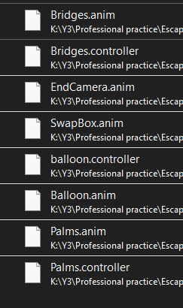

**Scripts:**

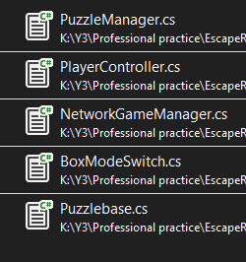

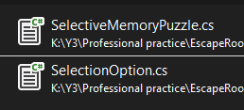.

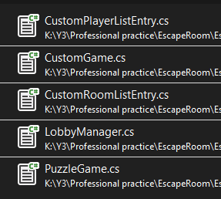

**Scenes:**

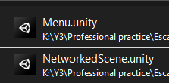

(The networked scene is the main gameplay level where I did the environment using 3rd party assets)